**MSSE 500 - Assignment Submission Document**

**Name: Chad Conway**

**Date: 10 / 17 / 2017**

**I. Assignment Name: Hangman**

# II. Learning Objectives: (here is an example)

* Draw gallows and stick person on canvas when player makes a wrong guess
* Display an alphabet with events to remove characters that have been selected
* Use an external script page to hold 5 categories of words with 10 words in each
* Player clicks on alphabetical characters in an attempt to guess the current word
* Player may select from five categories of words

III. **Abstract** –

* Game screen consists of a "flex" design. Design includes:
  + A title "header"
  + 3 "flex-items" positioned horizontally and will resize depending on screen resolution and size:
    - The gallows canvas on the left.
    - The "wordBlock" in the center displays first game categories, then the current word to be guessed
    - An "alphabetBlock" furthest right which contains all letters of the alphabet initially. As the user clicks a selection, the letter is removed and either the letters are revealed in the current word. or another portion of the gallows is drawn with animation.
  + Game consists of animation elements:
    - Gallows-each section is drawn with animation.
    - If the player loses, the stick figure in the gallows swings back and forth.
  + Modals are used to indicate a win or loss. Closing the modal resets the game.
* Game build is modular. Consisting of:
  + Javascript files:
    - **gameBoard.js:**
      * *setup()* – Onload clears canvas and word blocks. Calls getCategory() for initial selection.
      * *drawAlphabet()* – Fills the "alphabetBlock" flex item with the characters of the alphabet.
      * *drawWord()* – Draws the current word to solve. Grayed boxes show spaces, and each new word, if multiple words, begins on a new line.
    - **controller.js:**
      * *getCategory()* – Reads **words.js** and displays the categories of words.
      * *getWord() –* Selects random word from selected category.
      * *letterChoic() –* Takes user selected character from alphabetBlock. Checks to see if the current word contains a match, if so reveals it. If not, calls *drawHangman().*
      * *showWord()* – If player loses, reveals the unsolved characters of the current word.
    - **animation.js:**
      * *drawHangman() –* Draw next section of gallows or stick player.
      * *endAnimation() –* If player loses, swings the stick player from the gallows.

## **IV. Statement of Originality**

This game is the original work of myself, programmatically and design-wise. The coneptual framework for Hangman is the property of the whoever so holds the current copyright, if any.

## **V. Screen-shot of design document or application (also include a figure title and note for**

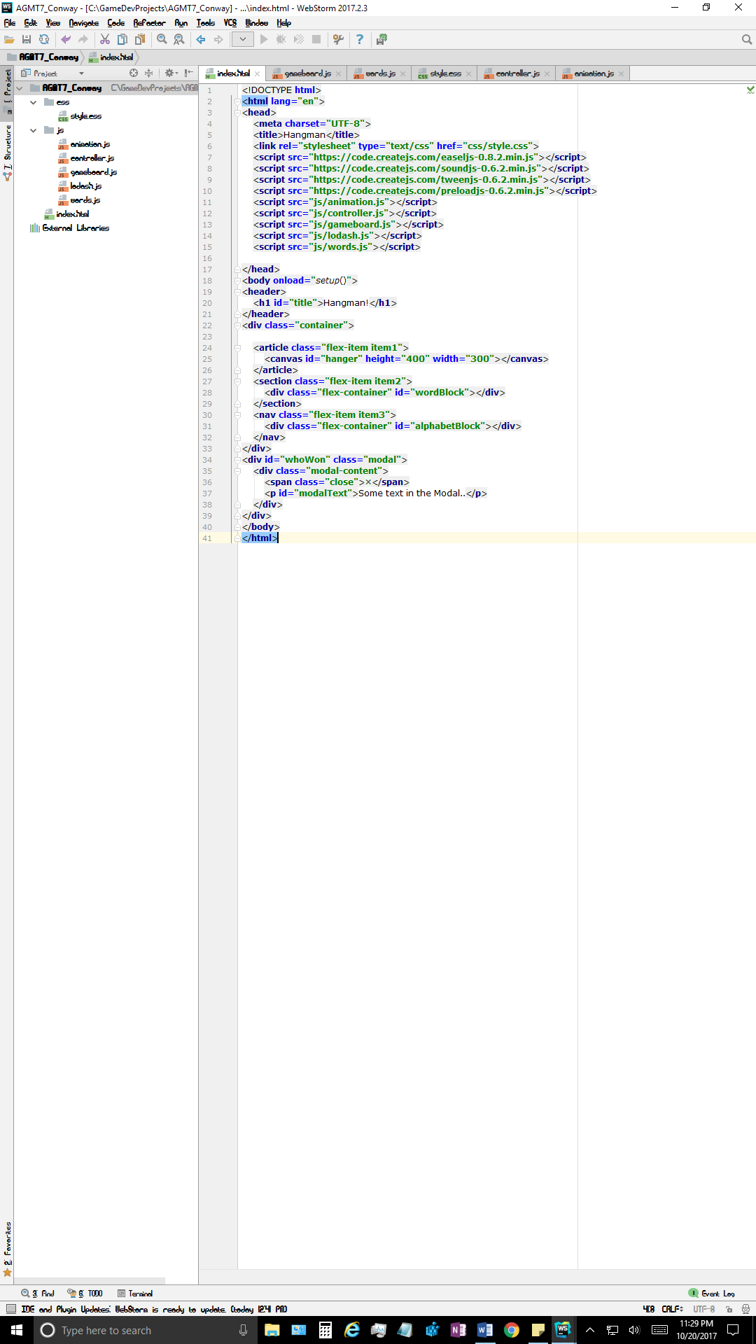

*Screenshot 1 – Index.html*

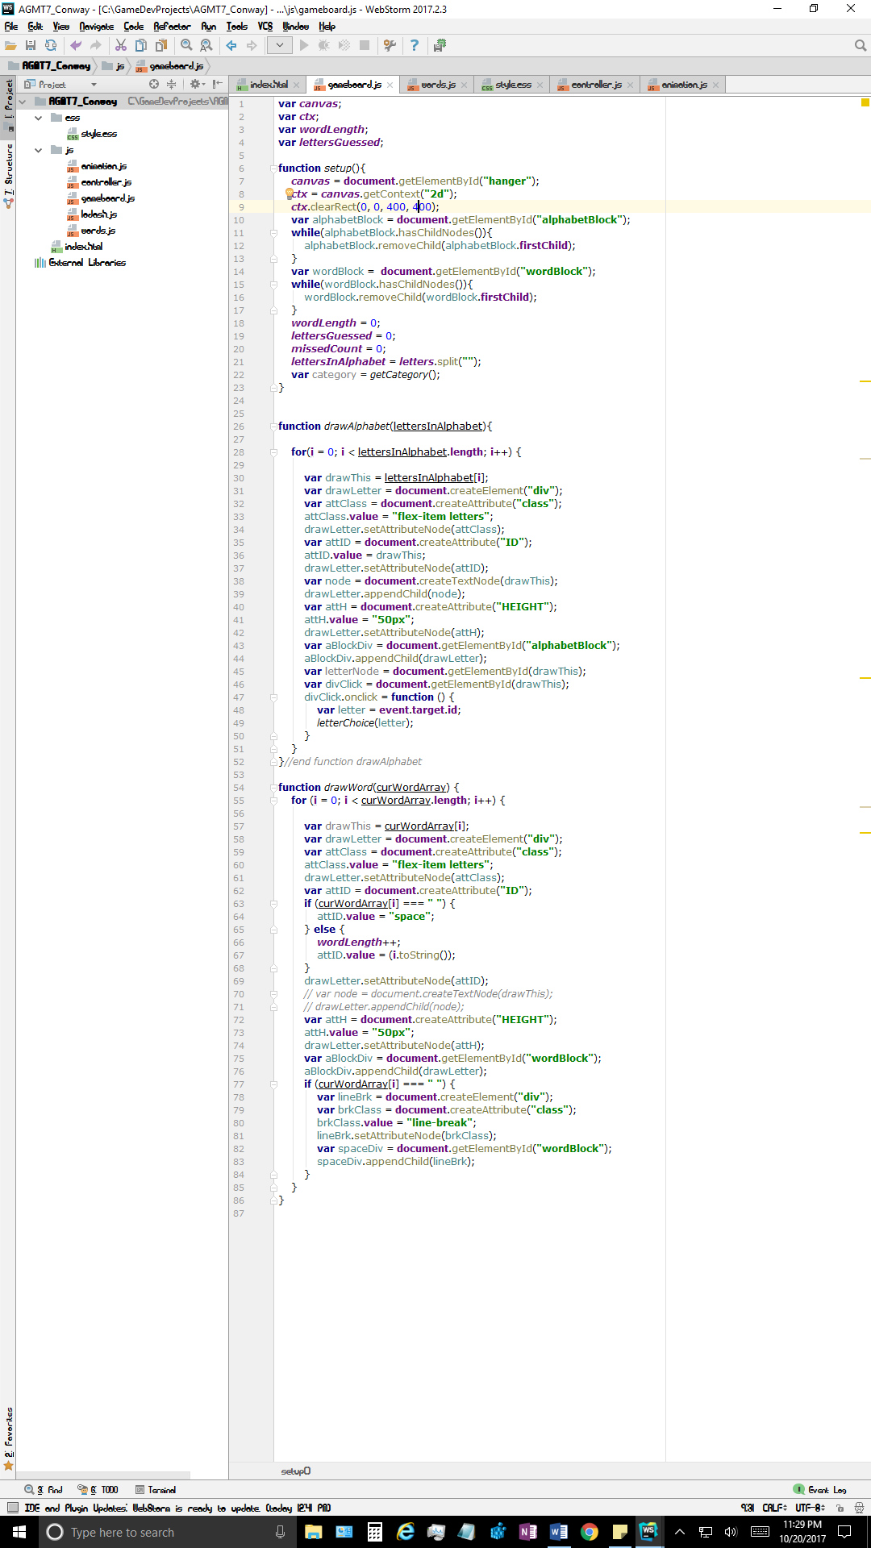

*Screenshot 2 – gameboard.js*

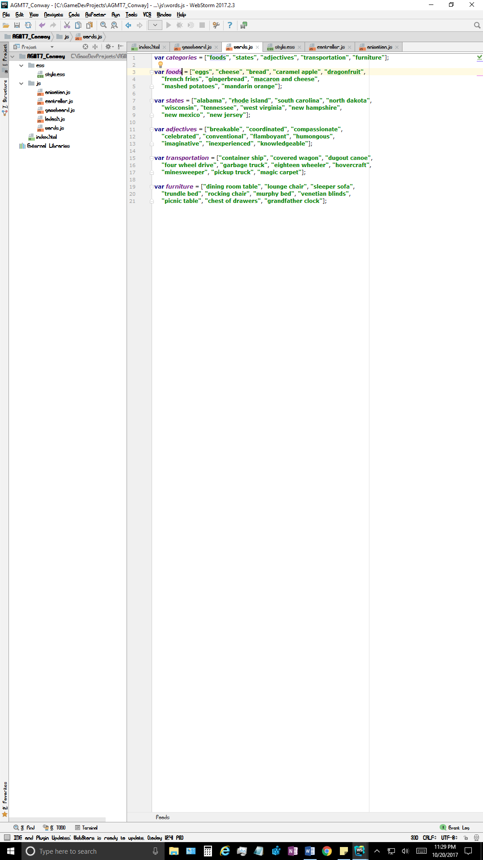

*Screenshot 3 – words.js*

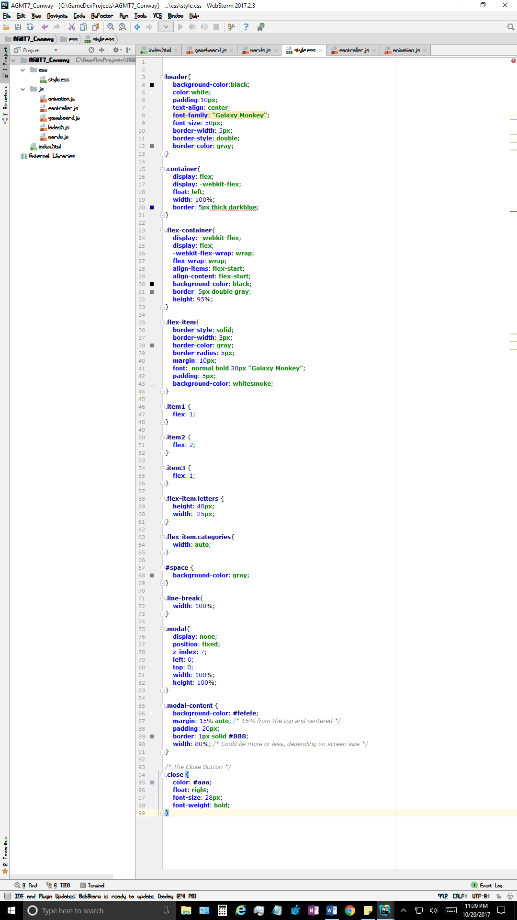

*Screenshot 4 – style.css*

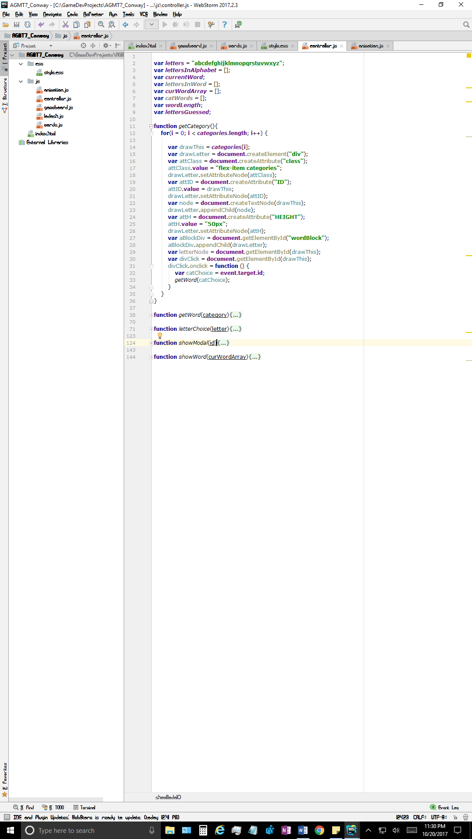

*Screenshot 5 – controller.js function getCategory()*

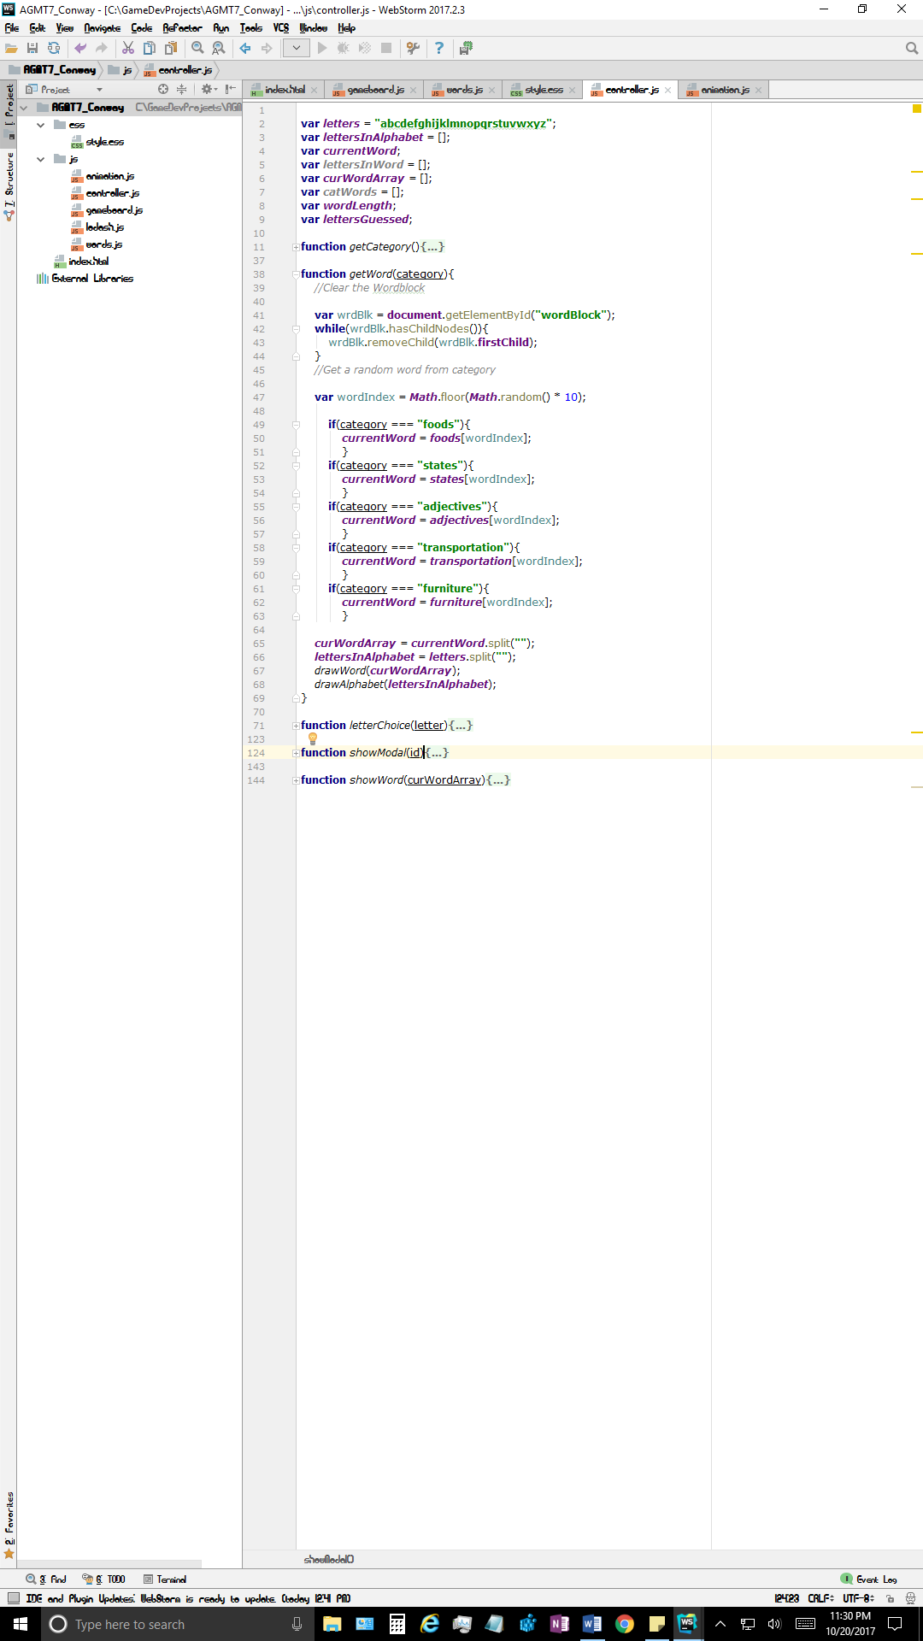

*Screenshot 6 – controller.js function getWord()*

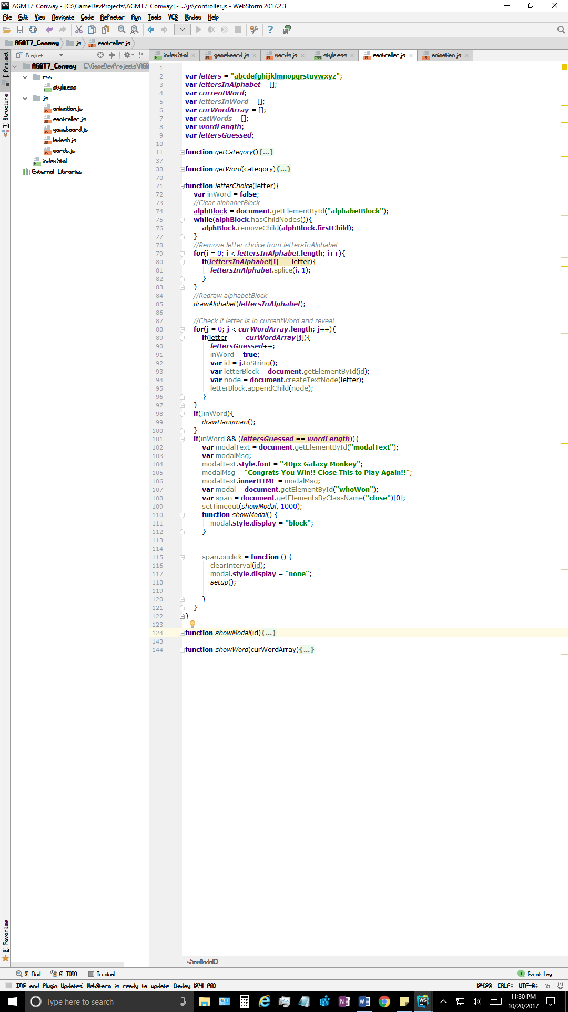

*Screenshot 7 – controller.js function letterChoice()*

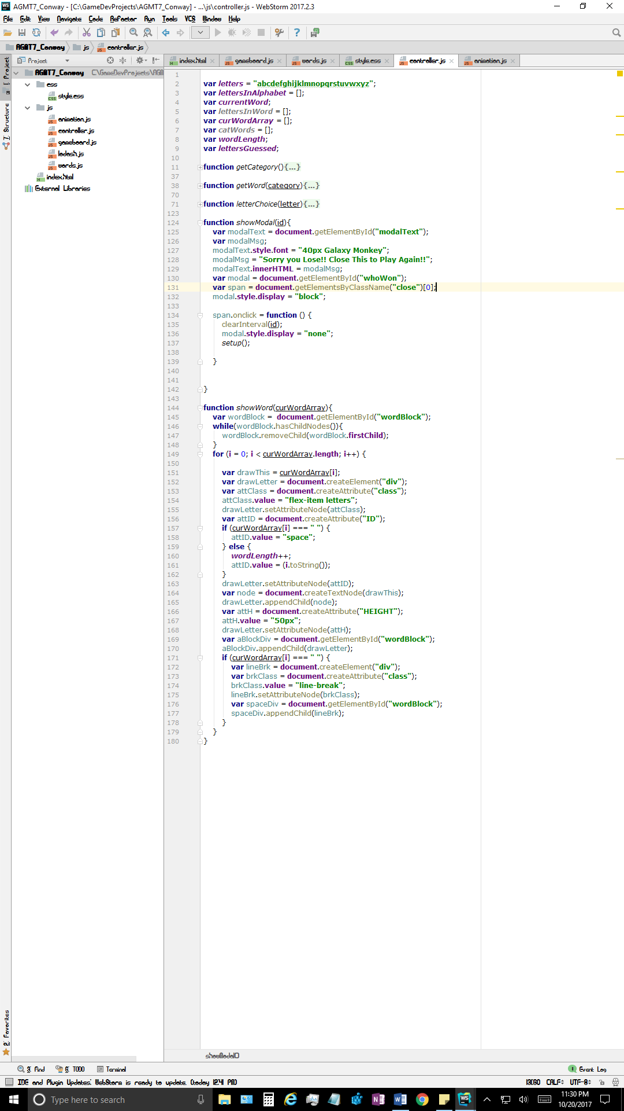

*Screenshot 8 – controller.js function showWord() & showModal()*

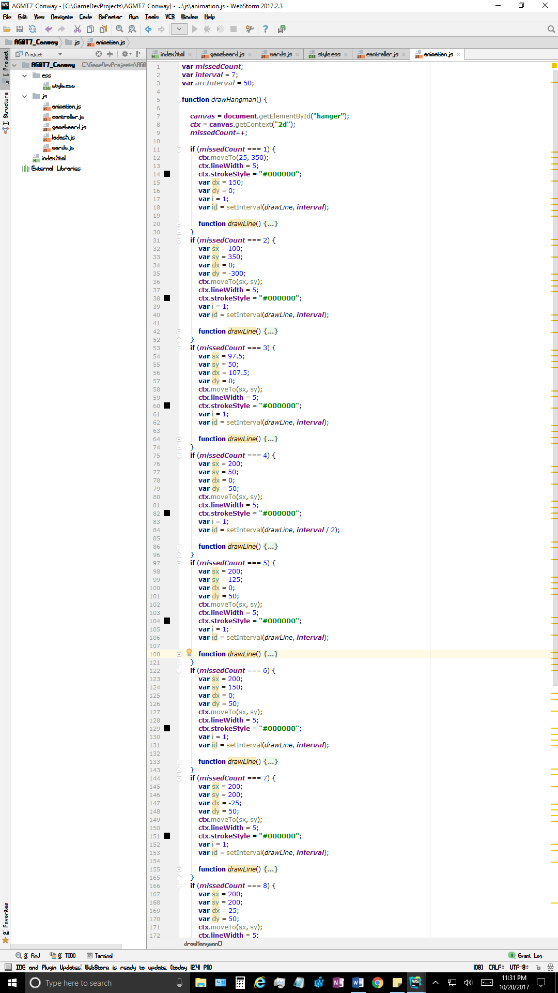

*Screenshot 9 – animation.js function drawHangman()*

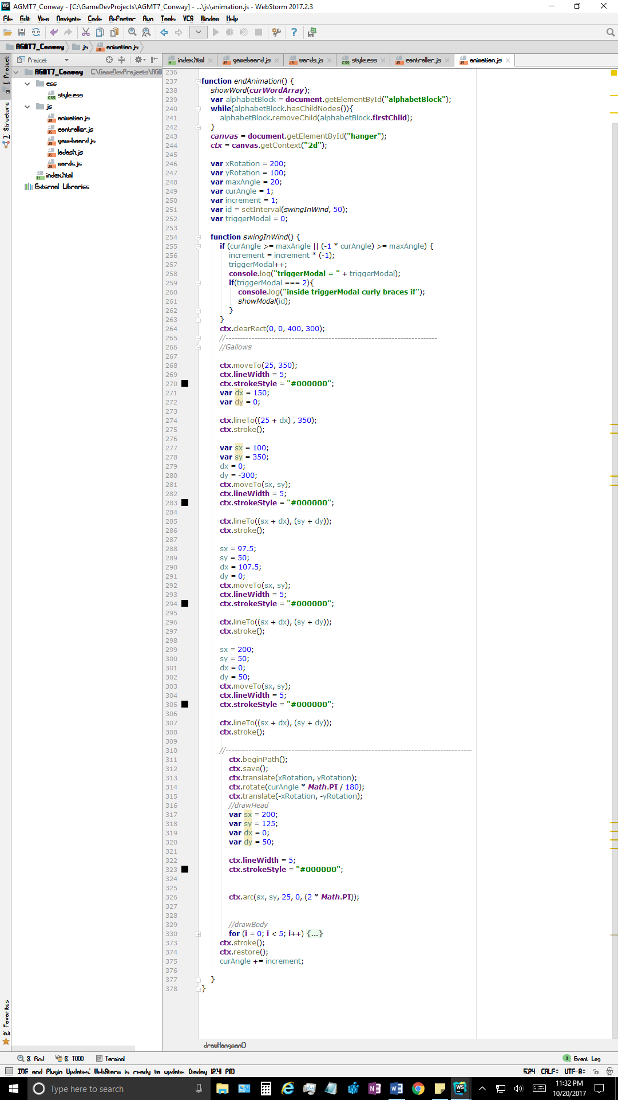

*Screenshot 10 – animation.js function endAnimation()*

*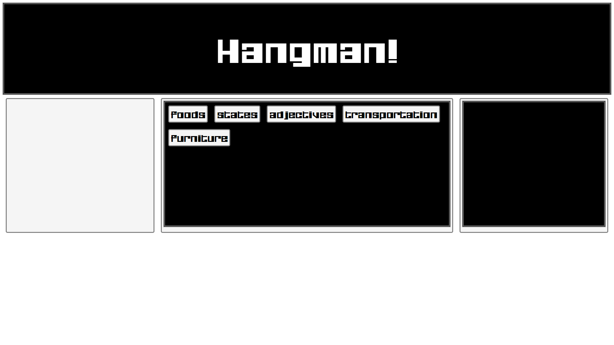Screenshot 11 – Gameplay – Opening Screen*

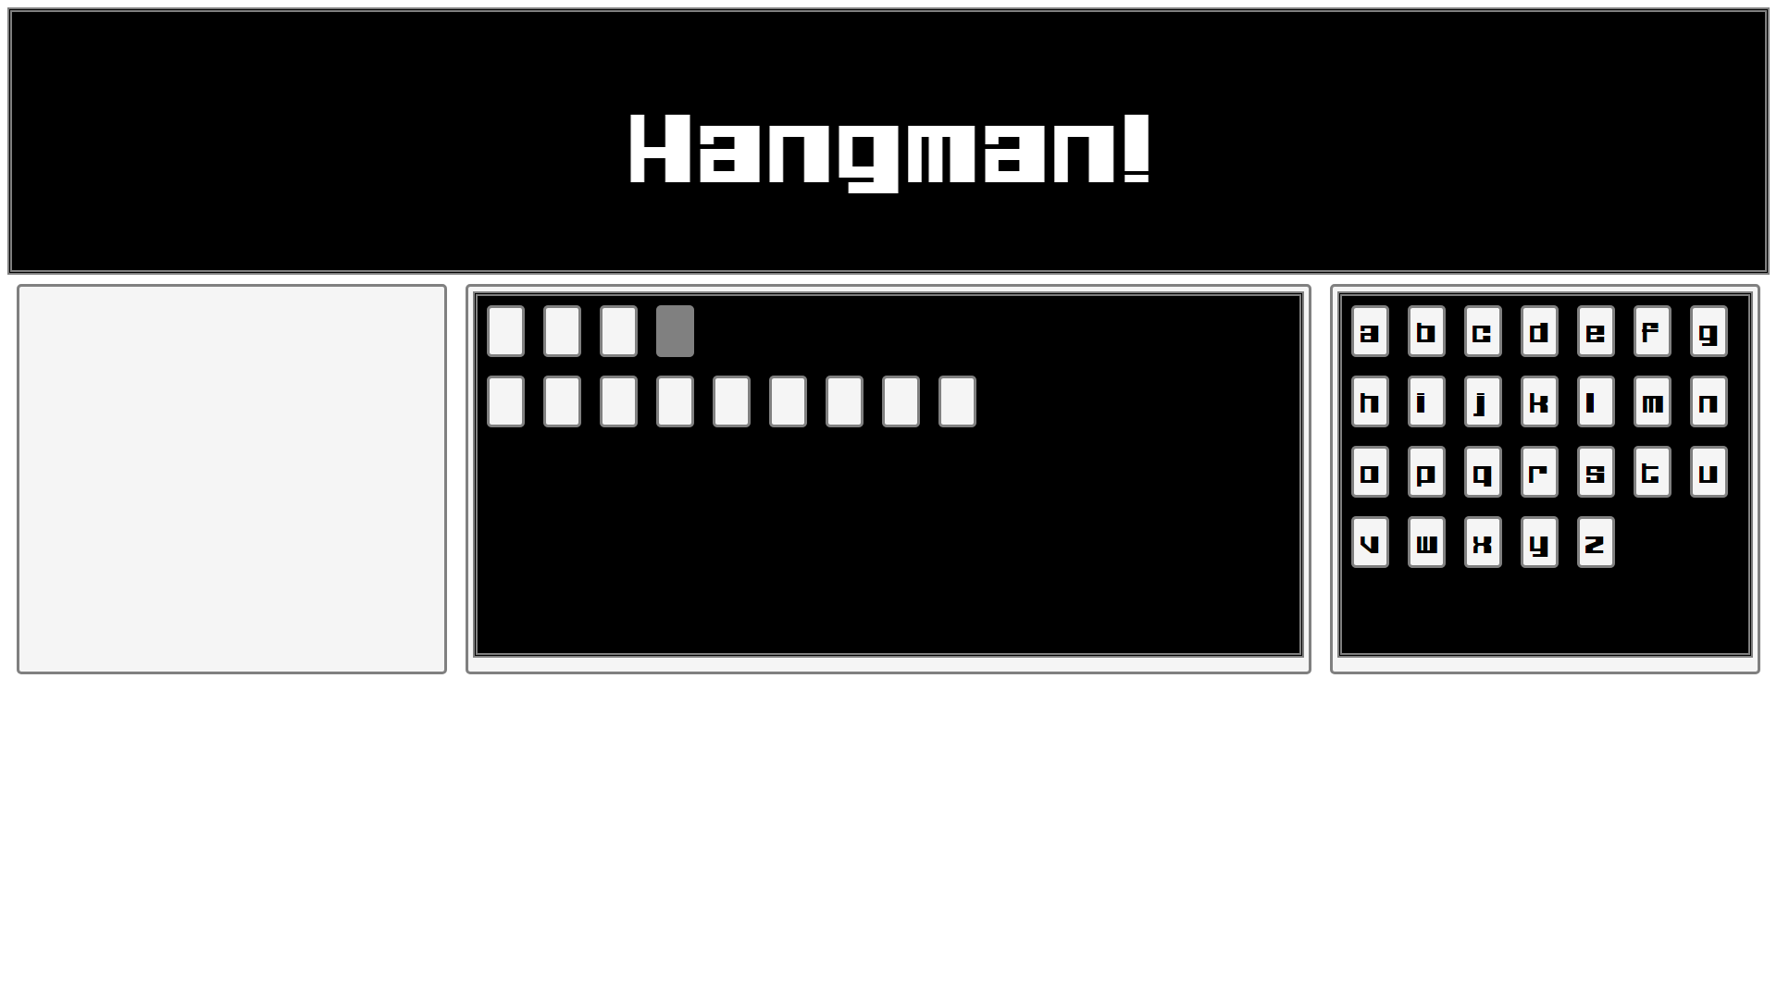

*Screenshot 12 – Gameplay – After category selection*

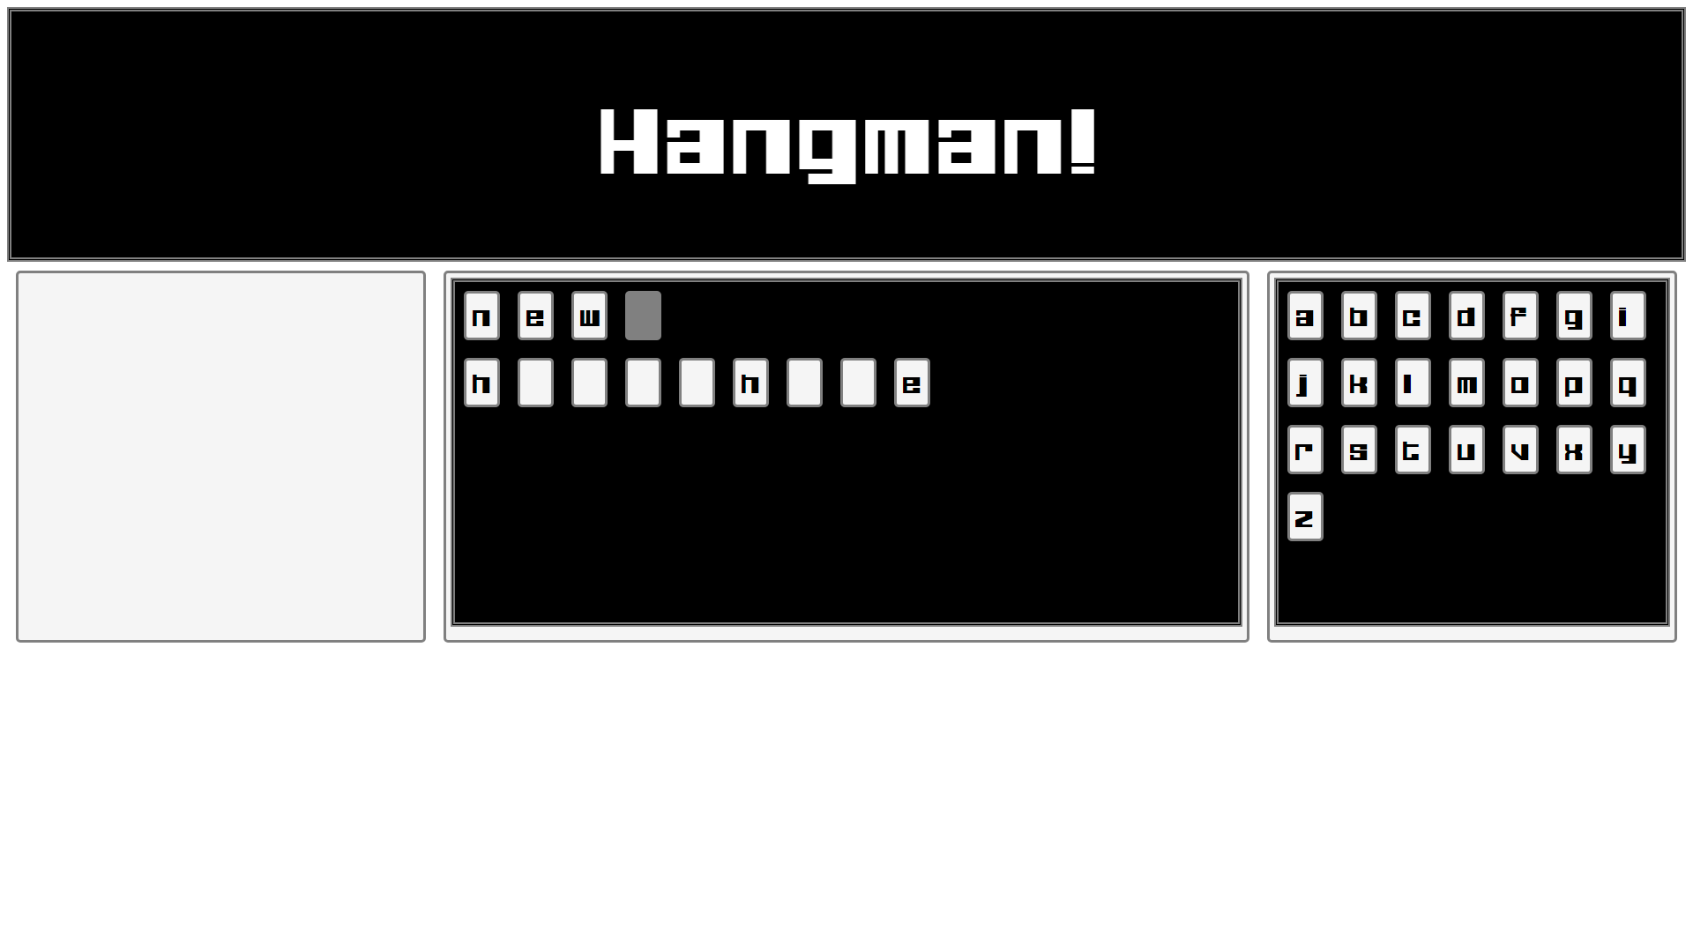

*Screenshot 13 – Gameplay during word guessing*

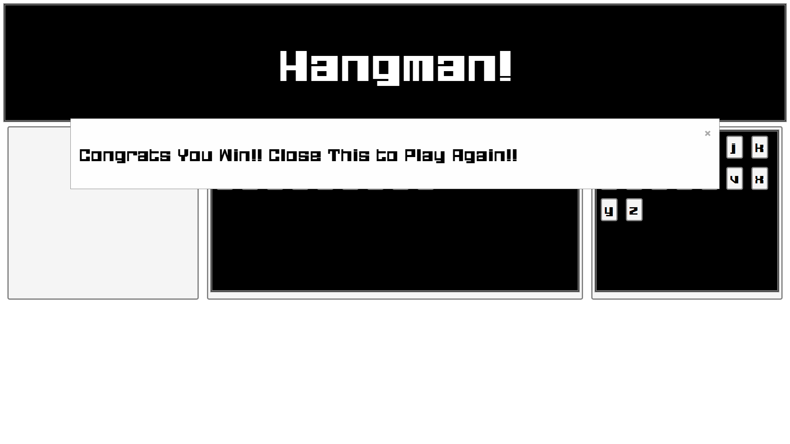

*Screenshot 14 – Gameplay winning modal*

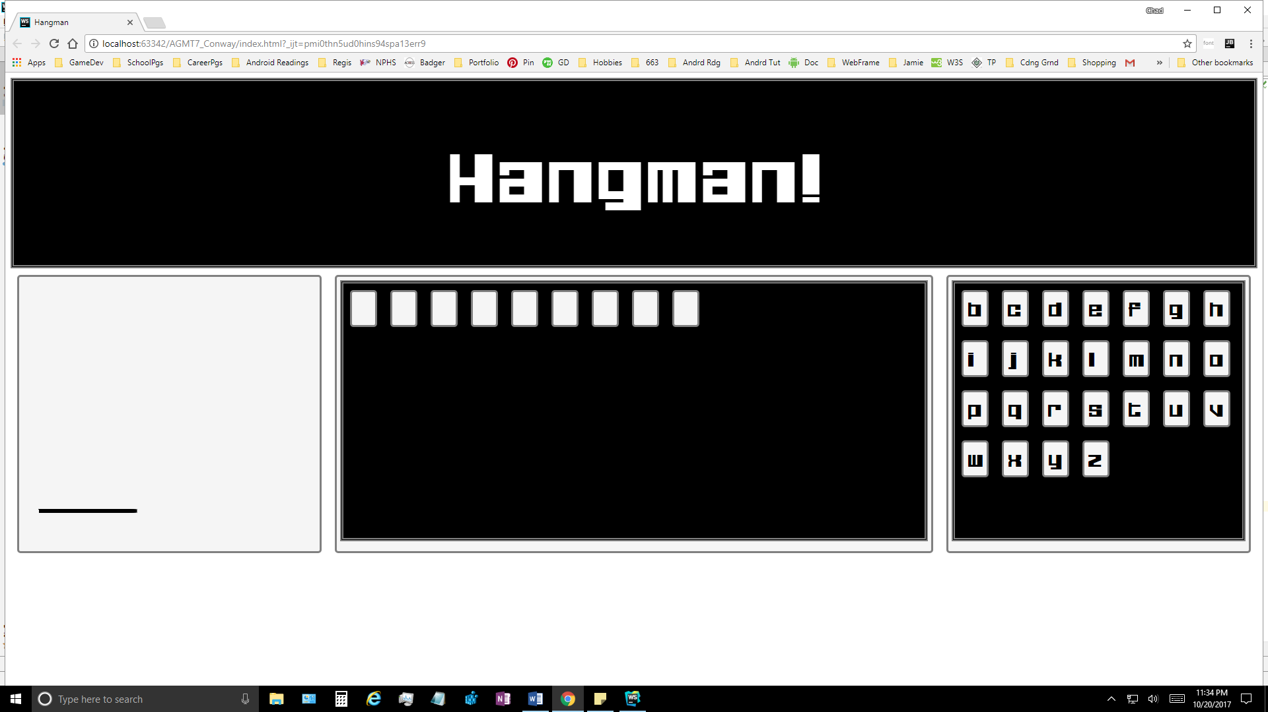

*Screenshot 15 – Gameplay first gallows animation*

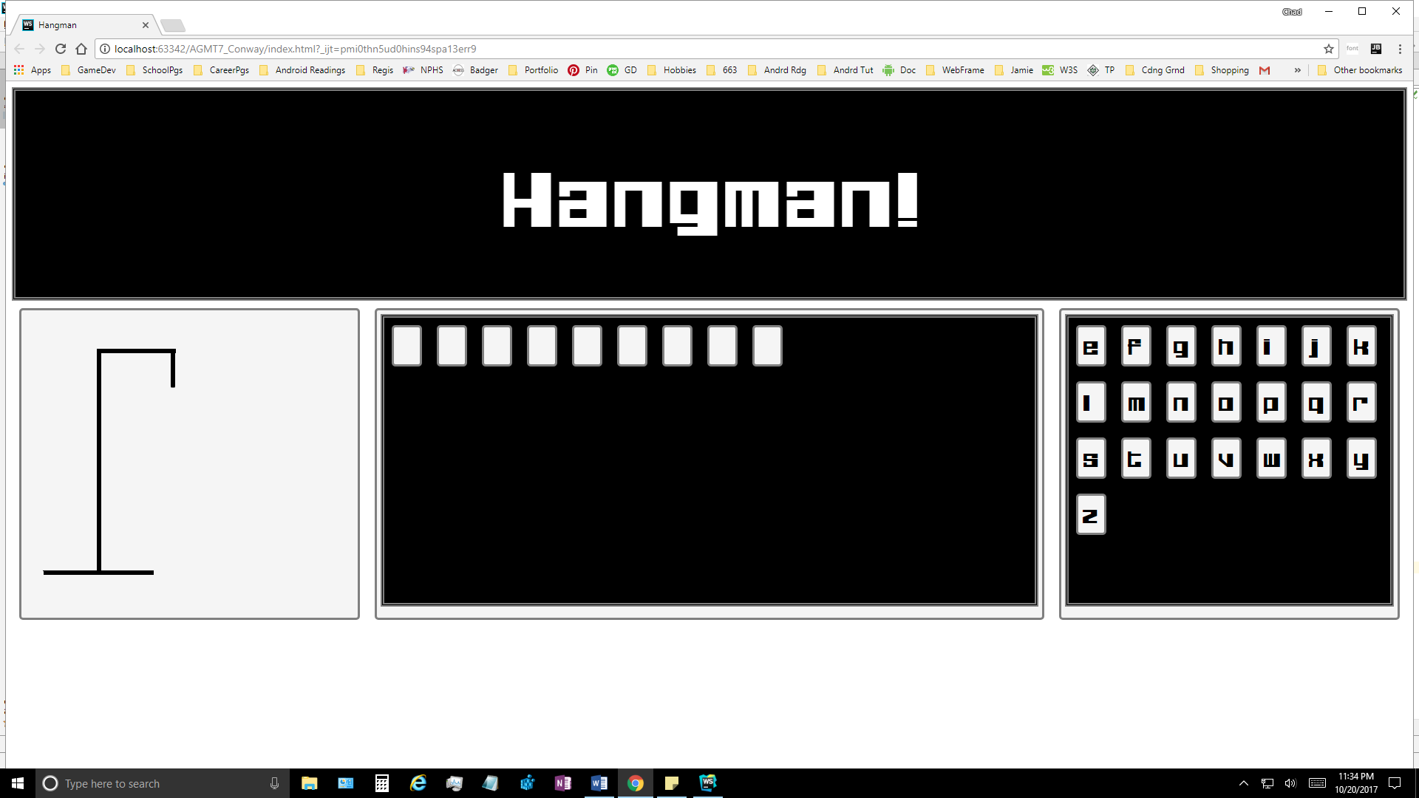

*Screenshot 16 – Gameplay allows drawn, ready for stick figure*

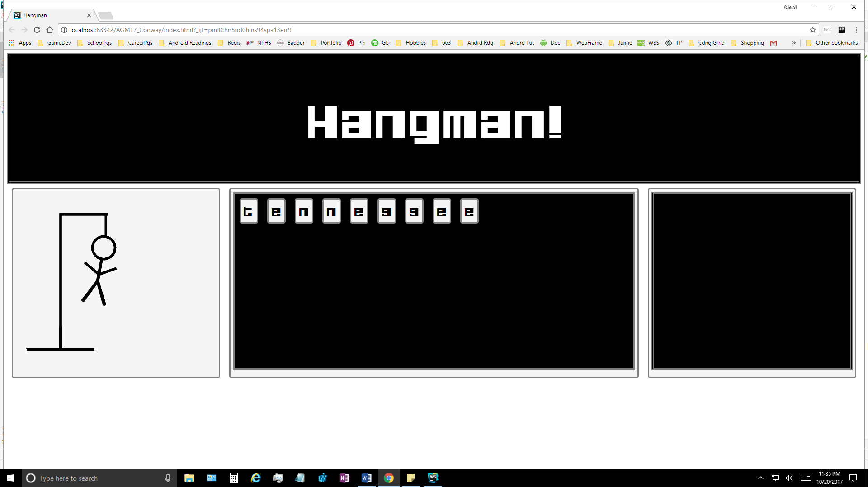

*Screenshot 17 – Gameplay player lost, word revealed, gallows begins swinging*

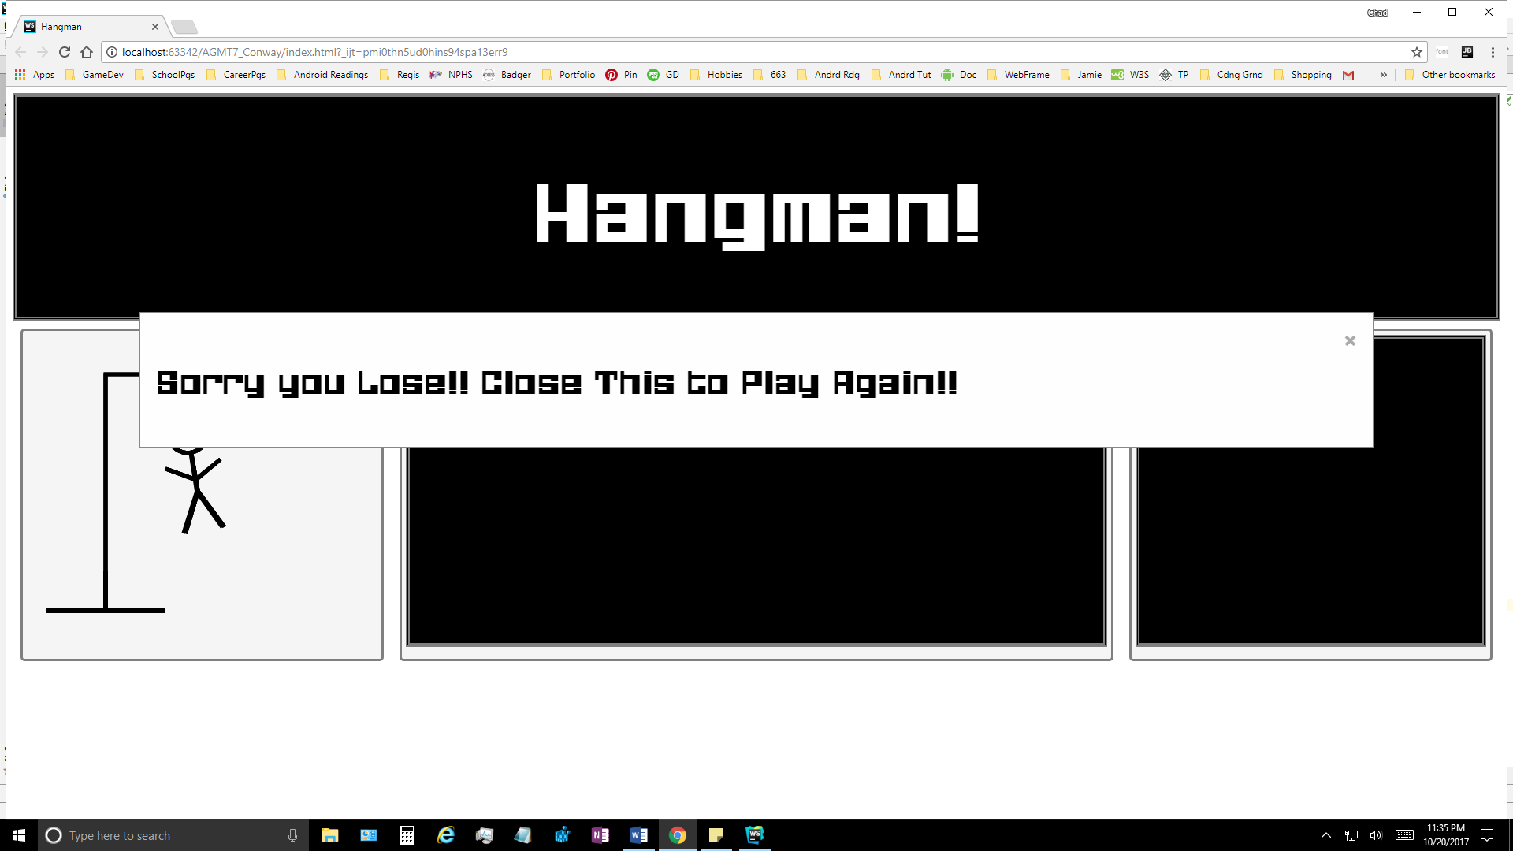

*Screenshot 18 – Gameplay player lost, modal revealed after delay*